**HUMAN COMPUTER INTERACTION**

**QUIZ NO. 2**

**[CLO2, PLO2]**

**BSE 6A 05 Marks**

Q1. Relate Gestalt principle(s) with the given interfaces with an explanation:

(a) 

(b) 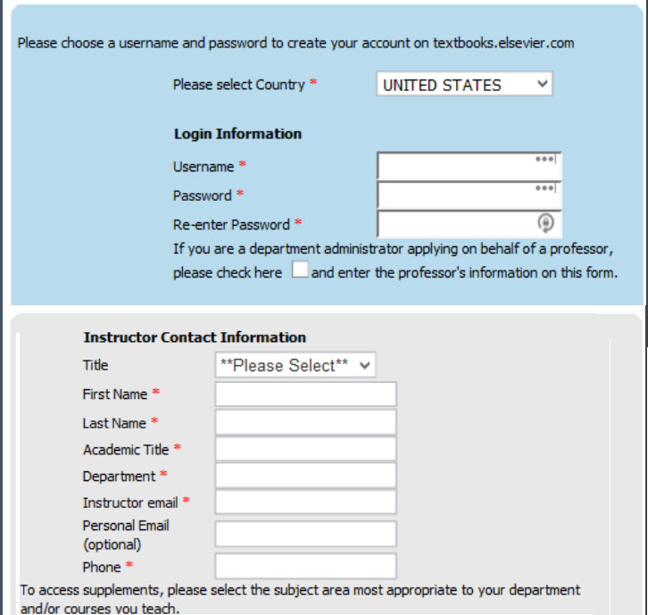

Q2. Demonstrate the application of Figure/Ground in website design.